2026
Lwandle Magudelela
IIE Advtech
1/1/2026
DreamGarage
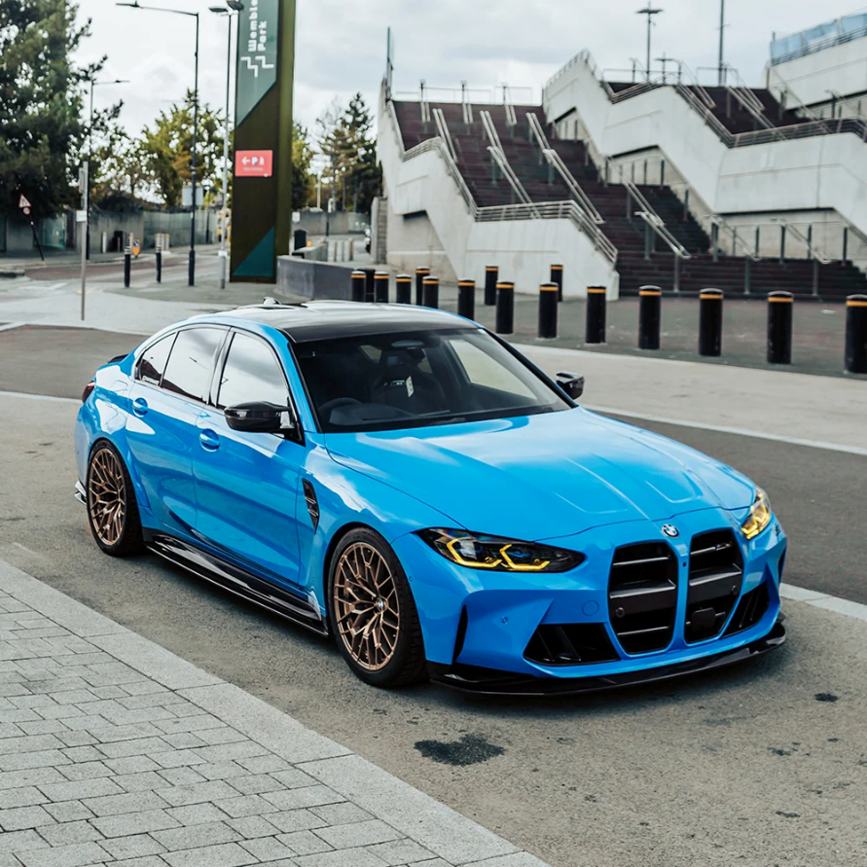

1. Organisation Overview:
Name: [DreamGarage – Automotive retail and Customization]
- History of the organisation.
Dream Garage was established in 2024 as an automotive retail business created to provide car enthusiasts and everyday vehicle owners with a convenient place to purchase vehicles, automotive parts, accessories and customization products. The organisation was founded after identifying the gap between traditional car dealerships and modern online shopping, where customers often have to visit multiple businesses to find everything they need for their vehicles.
- Mission and Vision statements.
- Missions Statement.
Our mission is to provide customers with high quality vehicles, automotive products and customisation services while delivering an innovative, convenient and customer-focused shopping experience.

- Vision Statement
Our vision is to become a leading automotive retail brand in South Africa, recognised for innovation, quality, affordability and helping every customer build their dream car
- Target audience.
DreamGarage primarily targets car enthusiasts, vehicle owners and potential car buyers between the ages pf 18 and 45. The business is aimed at people who are interested in purchasing vehicles, upgrading their cars, or improving their driving experience through automotive accessories and customisation.
2. Website Goals and Objectives:
- The main goal of the DreamGarage websites is to create an easy-to-use platform where customers can browse and purchase vehicles , automotive parts, accessories and customisation products.
- Website goals
- Increase awareness of the DreamGarage brand and its automotive products.
- Allow customers to browse and purchase vehicles, parts and accessories online.
- Provide customers with an interactive “Build Your Dream Car” customisation feature.
- Increase customer enquiries and potential sales through the website.
- Provide customers with information about available vehicles, products and services.
- Key performance indicators
The success of the website can be measured using:
- Number of website visitors.
- Number of products or vehicles viewed
- Number of completed purchases
- Number of customer enquiries
- Number of customers using the car customisation feature
- Number of returning customers
3. Current Website Analysis (if applicable):
- Since DreamGarage is a new business, there is currently no existing website to analyse.

However, the proposed website will address common weaknesses found in traditional automotive retail websites, such as limited customisation options, difficult navigation and a lack of online purchasing functionality.

The DreamGarage website will focus on providing a modern, user-friendly and interactive experience where customers can browse products, customise vehicles and make purchases online.
4. Proposed Website Features and Functionality:
The Dream Car Garage website will be an online retail platform where customers can browse and enquire about luxury, sports and performance vehicles.

- Homepage

- The homepage will introduce Dream Car Garage and create a strong first impression. It will feature attractive images of vehicles, a short introduction to the business, featured vehicles and clear navigation to the other pages.

- About Us

- The About Us page will provide information about Dream Car Garage, including the history of the organisation, its mission and vision, and what makes the business different from other vehicle retailers.

- Products/Services

- The Products/Services page will display the vehicles available for purchase. Customers will be able to view important information such as the vehicle's make, model, year, price, mileage and specifications. The page will allow customers to browse the available vehicles and identify cars that suit their preferences.

- Enquiry

- The Enquiry page will allow customers to submit an enquiry about a specific vehicle or service. Customers will be able to enter their details and provide information about what they are interested in. This will allow Dream Car Garage to respond to potential customers.

- Contact

- The Contact page will provide customers with the business's contact information, including its email address, telephone number and physical location. A contact form can also be provided so that customers can easily communicate with the business.

- Overall Functionality

- The website will have clear navigation between all required pages and will be designed to work on desktop, tablet and mobile devices. Buttons and forms will be simple and easy to use, allowing customers to browse vehicles and contact Dream Car Garage without difficulty.

5. Design and User Experience:
- Colour Scheme:

- The proposed colour scheme for Dream Car Garage will use sky blue and black. Black will be used as the main background and for headings or important sections, giving the website a professional and premium appearance. Sky blue will be used as an accent colour for buttons, links, highlights and other interactive elements. The combination will give the website a modern, sporty and eye-catching look that suits the automotive theme.

- Typography:

- A modern, easy-to-read font such as Montserrat or Poppins will be used. Larger and bolder fonts will be used for headings, while smaller, simple text will be used for paragraphs and vehicle information.

- Layout and Design:

- The website will have a clean and modern layout with a navigation bar at the top of each page. Vehicle images will be displayed prominently, while information will be organised into clear sections. Sky blue buttons and highlights will help important actions stand out against the black sections.

- User Experience Considerations:

- The website will have simple navigation so that users can easily access the Home, About Us, Products/Services, Enquiry and Contact pages. The design will be consistent across all pages, with the sky blue and black colour scheme used throughout. The website will also be responsive so that it can be viewed comfortably on computers, tablets and mobile phones.

- Low-Fidelity Wireframes:

- The wireframes will show the basic layout and information hierarchy of the website before the final design is created. They will include the navigation bar, images, headings, vehicle information, buttons and enquiry/contact forms.
6. Technical Requirements:
- HTML5 – Website structure and content.
- CSS3 – Styling, layout, animations and responsive design.
- JavaScript – Interactive features and calculations.
- Web hosting – To store and publish the website.
- Domain name – A professional domain such as dreamgarage.co.za.
- Database – To store customer accounts, vehicles, products and orders if required.
- Responsive design – To ensure the website works on different screen sizes.
7. Timeline and Milestones:
- Week 1
- Research the organisation, target audience and competitors.
- Week 2
- Plan the website structure, features and navigation.
- Week 3
- Create low-fidelity wireframes and finalise the website design.
- Week 4
- Develop the homepage, About Us and Contact pages.
- Week 5
- Develop the Vehicles and Parts & Accessories pages.
- Week 6
- Implement the Build Your Dream Car feature and shopping cart.
- Week 7
- Test the website, fix errors and improve responsiveness.
- Week 8
- Complete final changes, documentation and prepare the website for submission.
8. Budget:
The estimated budget for developing and maintaining the DreamGarage website is based on the costs associated with domain registration, hosting, development and ongoing maintenance.
Estimated Costs
- Domain registration (.co.za): R150 per year
- Web hosting: R1,200 per year
- Website development: R5,000
- Website maintenance and updates: R1,500 per year
- SSL/security certificate: R0 – R500 per year
- Estimated initial cost: R6,350 – R6,850
The development cost covers the design, coding and implementation of the website. Hosting, domain registration and maintenance would be recurring costs required to keep the website available and updated.

9. References:
  - References listed here are unique to the chosen organisation and the researched documentation of the Website Project Proposal. The references listed in this document and the general references used to complete Part 1 will be compiled in the README.md document in the repository for the entire PoE.

